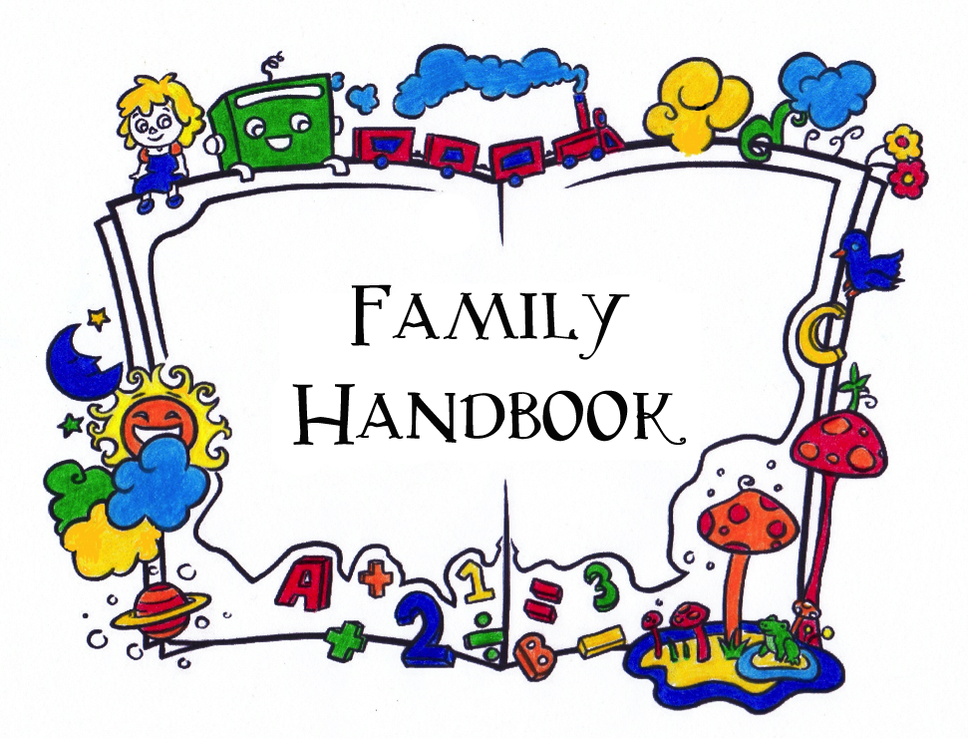

NEW COLLEGE CHILD CENTER

Learning with joy, growing with confidence

2023-2024

Welcome to the New College Child Center!

This Family Handbook has been written as an informative guide for your reference while your children are with us. It is intended to give you an overview of the NCCC program, and to help you and your child navigate the preschool waters. In this handbook, you will find information about NCCC’s educational philosophies, school practices, and administrative policies. Center staff, board members, and parents have worked to create a handbook that will be helpful
and transparent.

CONTACT INFORMATION
540 58th Street*
Sarasota, FL 34243
(941) 360-5590
* 58th St appears on some maps as Pine Park Road.
ncchildcenter@gmail.com
www.newcollegekids.org
Tax ID # 20-1226815

TABLE OF CONTENTS

CONTACT INFORMATION 1
TABLE OF CONTENTS 2
ABOUT NEW COLLEGE CHILD CENTER 4
Mission 4
Non-Discrimination Statement 4
Licensing & Legal Status 4
Location 4
The Director 5
The Board 5
The Staff 5
NCCC History 5
EDUCATIONAL PROGRAMS 6
Overview 6
Classrooms 6
The Curriculum 6
NCCC POLICIES 8
Enrollment 8
Tuition 8
Registration Forms and Initial Deposit 9
Medical Forms 10
Immunization Policy 10
Family Volunteer Requirement 10
Calendar 11
Confidentiality 11
Cultural Diversity 12
Mandated Reporting 12
Staff Behavior 12
Illness 13
Head Lice 13
Medication 13
Food & Food Allergies 14
Discipline & Guidance 14
Accidents & Injuries 14
Photos & Videos 15
Security Cameras 15
Emergency Preparedness & Response 15
SCHOOL PROCEDURES 17
What To Bring 17
Cubbies 17
Clothes and shoes 17
Labeling 18
Food 18
Hand-Washing 18
Diapering 19
Toilet Training 19
Drop-Off & Pick-Up 19
Parking 19
Daily Schedule 20
Napping 20
Toys, Books, & Sharing 21
Birthday Celebration 21
Staff Babysitting 21
FAMILY INVOLVEMENT 22
Participation 22
Communication 22
First Day of School 23
Third-Day Blues 23
Special Events 23

The beautiful photographs in this handbook are courtesy of Blonde Cow Photography.
Cover art is by Sami Hannah (teacher, 2013-14).

ABOUT NEW COLLEGE CHILD CENTER

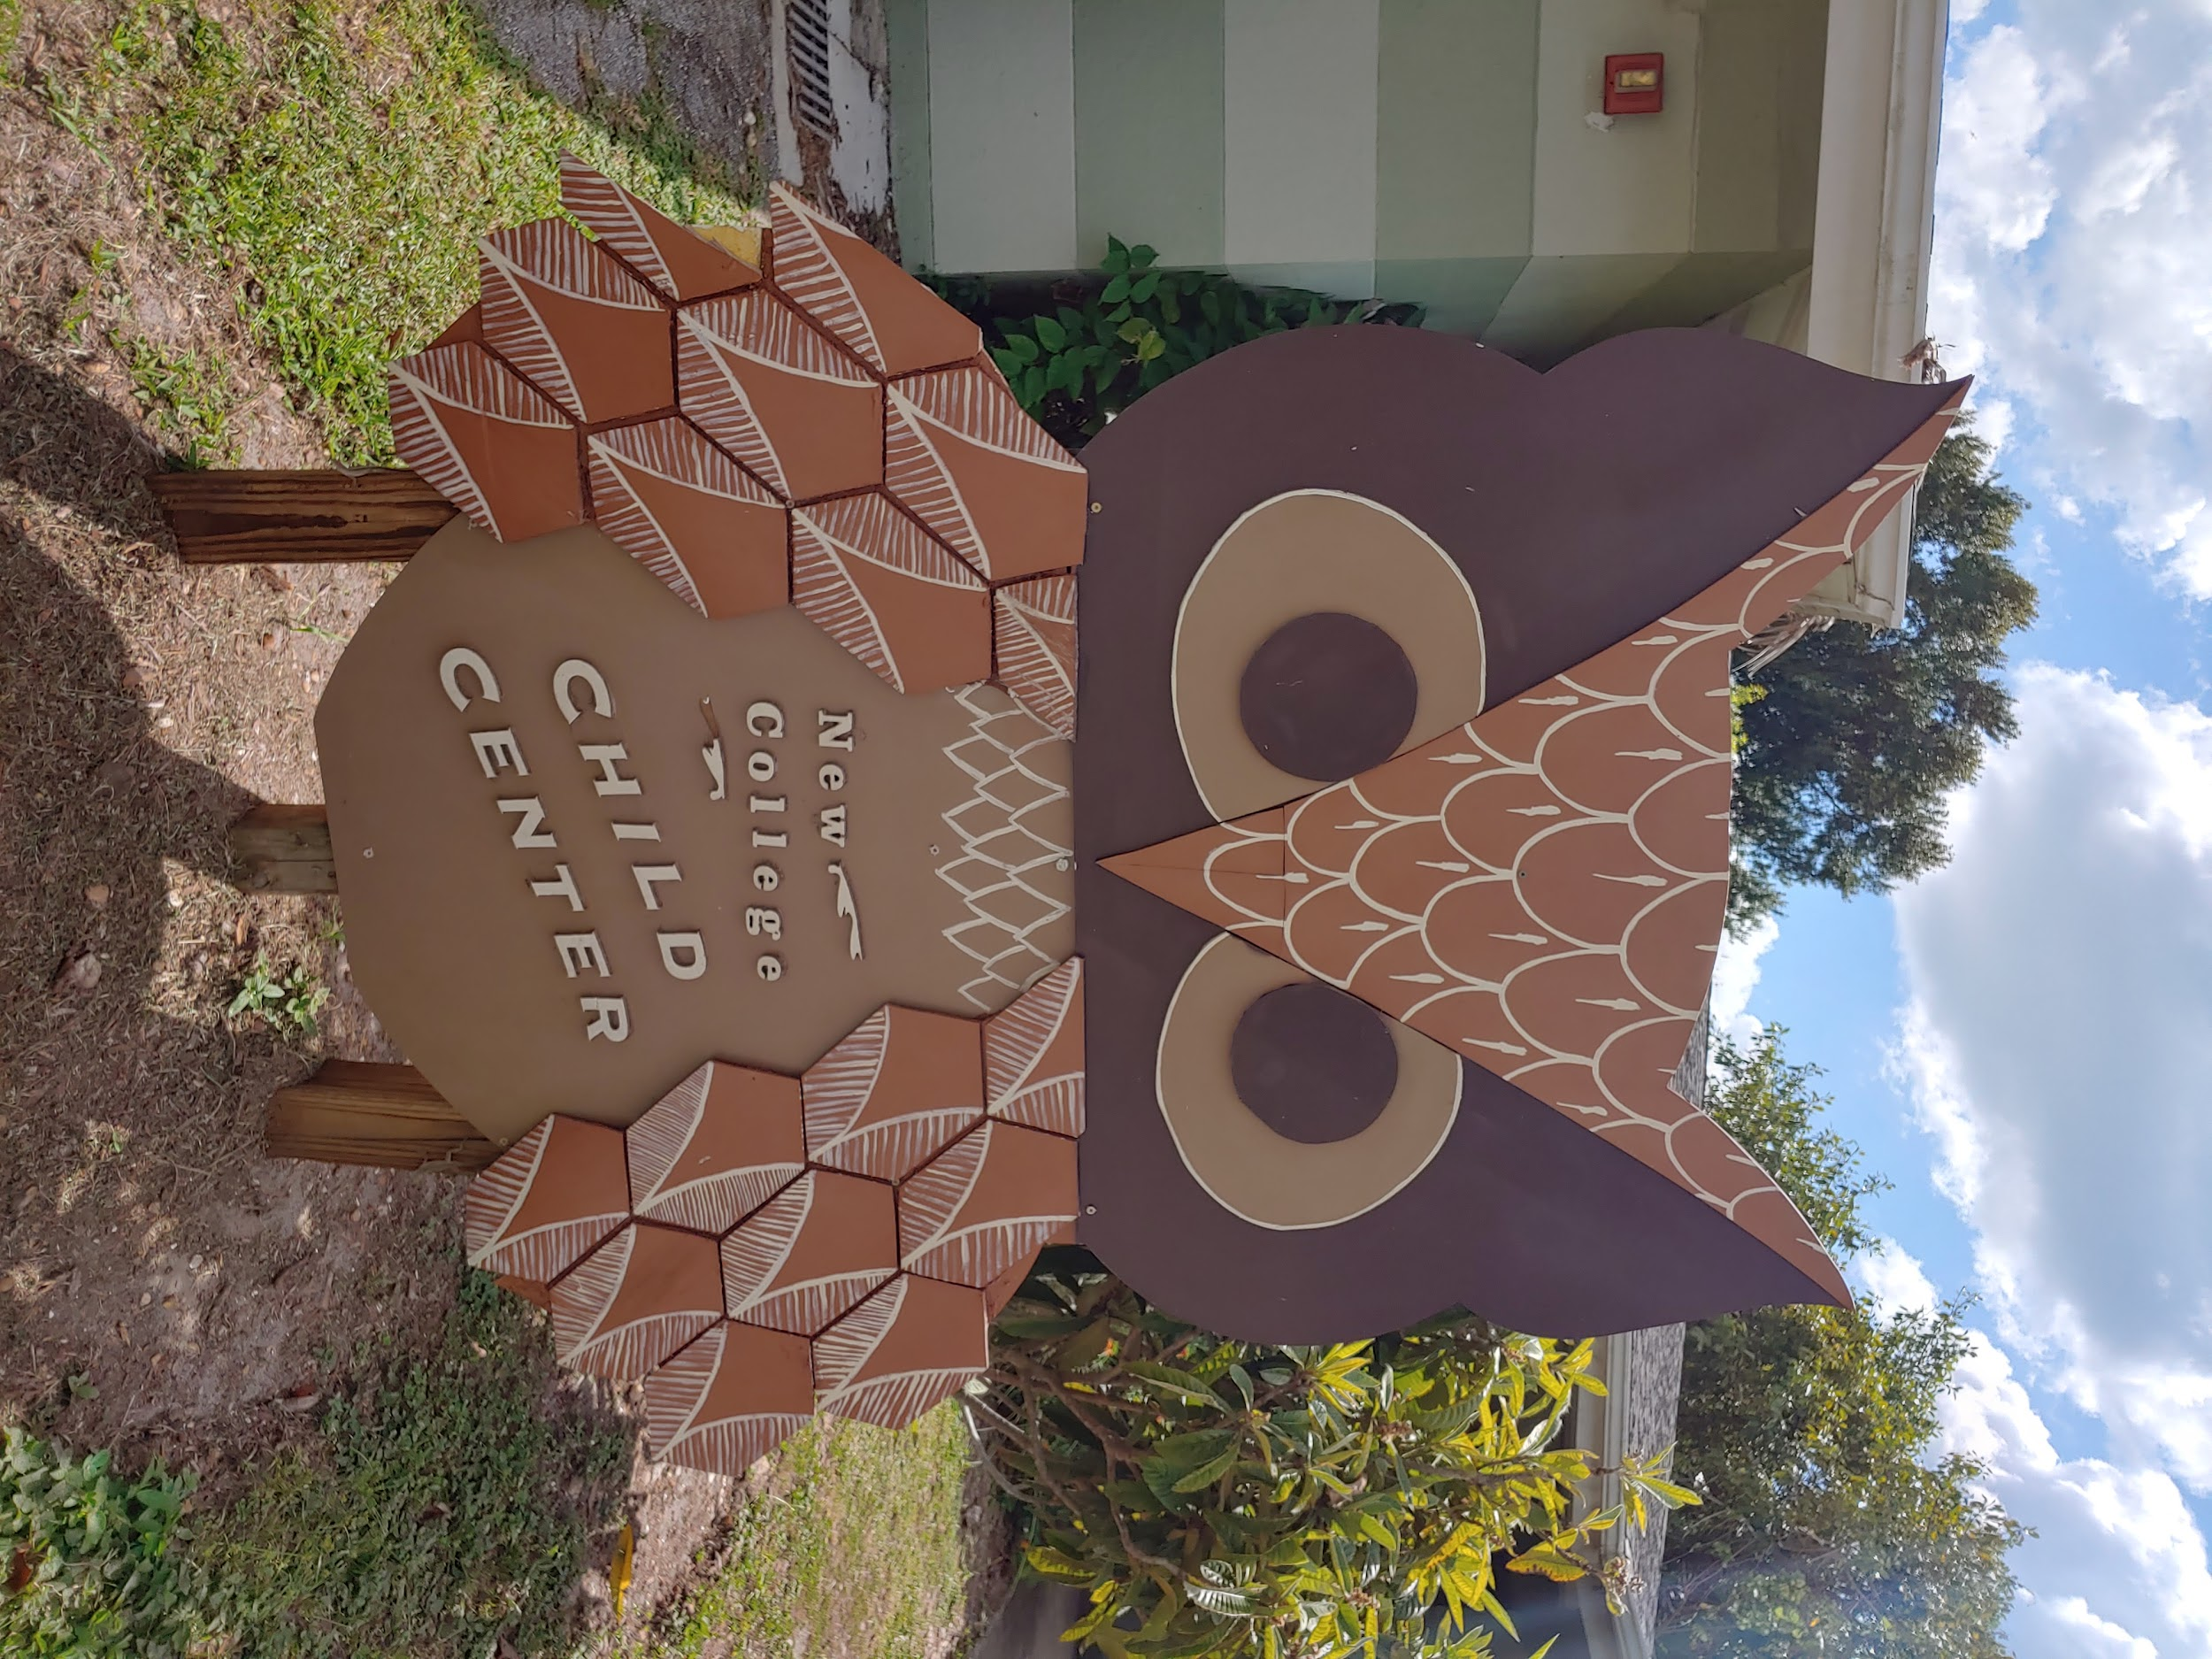

Mission

New College Child Center is an early learning center serving the New College campus and surrounding community. We provide a structured, nurturing educational environment focused on the development of the whole child through self-rewarding activities, exploration, and both individualized and social learning. We guide students as they develop into thoughtful, self-confident individuals who love to learn, and who are empowered to navigate their environment and their community with respect and intention.

Non-Discrimination Statement

New College Child Center is committed to mixed groupings of children. We believe that by building an inclusive environment where children are first recognized as members of their social group and peers they will learn to create a community that is rich in diverse abilities, skills, and cultures. To this end, we do not exclude or subject to discrimination any family, staff member, or volunteer based on race, color, religion, sex, sexual orientation, gender identity, national origin, age, disability, political beliefs, cultural heritage, or any other protected status.

Licensing & Legal Status

NCCC is licensed by the Sarasota County Department of Children & Families, and is in compliance with state and local regulations such as building codes, fire laws, and health & safety guidelines. It is also a 501(c)(3) nonprofit corporation (Tax ID # 20-1226815). While it is affiliated with New College of Florida, neither New College nor its affiliates provide direct subsidies to its operations.

Location

The children at NCCC are able to take advantage of the beautiful environment and stimulating academic resources of the New College campus. On any given day, they may be playing by the bayfront, planting trees on Arbor Day with members of the Physical Plant staff, reading books at the Jane Bancroft Cook Library, or learning about sea life at the Pritzker Marine Center.

The Director

NCCC Director Saran DeVaughn has over 15 years of experience in early childhood education.
She has worked with low-income care providers as well as programs for students with disabilities. She holds a AA degree in Early Childhood Education and completed BA coursework from State College of Florida. Ms. Saran was the administrative assistant to the program director of Children First, the Headstart-designee in Sarasota county, for 10 years. During that time, she assisted in grant writing of federal and local grants through Headstart, the Community Foundation of Sarasota, among others.

The Board

NCCC is overseen by a volunteer Board of Directors, all of whose members are parents of children at the school. The Board, which meets a few times a year, supports the work of the Director and assists in establishing overall school policy. You may ask the director for a list of current board members or find it on our website.

The Staff

NCCC currently employs five full-time staff members including the director. Their work is supported by a number of other part-time staff members, many of them students at New College of Florida; all paid staff receive training in First Aid and CPR, level 2 background screenings, 40 hours of training in early childhood education and ten hours per year of inservice training. Staff have three to four all-staff meetings per year and continue professional development in-house with weekly staff meetings for full time staff and training or observations on professional days. The staff also frequently shares among themselves articles and videos related to the early childhood environment.

The Center also benefits from the time and effort contributed by interns and volunteers, who are mostly drawn from the New College student body. Their presence allows staff and children to have more one-on-one or small-group interactions, and we are very fortunate to benefit from their fresh energy and enthusiasm for working and playing with children.

NCCC History

In 2004, a group of New College faculty and staff members and alumni banded together to create a child care center which would, in the words of our bylaws, “provide geographically and financially accessible child care of the highest quality,” “be a resource for the New College community widely construed,” and “nurture curiosity and discovery in arts, science, language, and cultures while fostering independence, confidence, and peer interaction.” In the fall of 2007, we achieved the status of a child care center and began to implement our original vision. Today, under the direction of current director Saran DeVaughn, the Center is filled with the children of faculty, staff, alums, students, and community members, learning and playing under the guidance of staff members, work/study students, and student volunteers.

EDUCATIONAL PROGRAMS

Overview
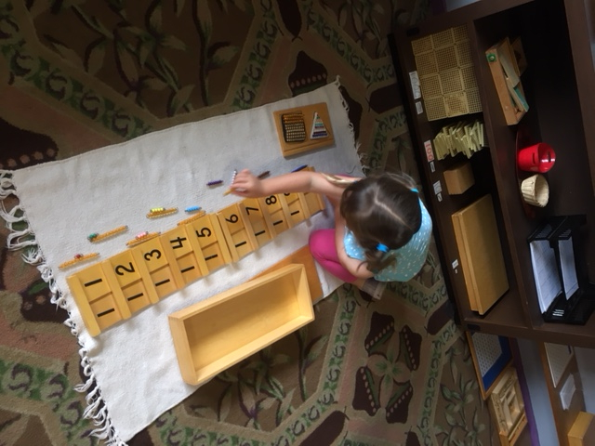
NCCC’s main purpose is to provide quality child care and education on a full- and part-time basis during the school year. In addition, we also offer two supplemental programs:

VPK (Voluntary Pre-Kindergarten): This is a state-funded Florida program that pays participating child care centers to have four-year-olds attend a school-year-long program for three hours a day to help families prepare their children to be more successful in kindergarten. VPK is not mandatory for students, but can work either independently or as a discount on our full-time rate. Ask the director if you have questions about VPK and your child.

Summer: While NCCC follows the New College of Florida and Sarasota County School calendars, we also offer summer camp. Staffing, tuition rates, and hours may differ from the rest of the year. You will most likely be asked early in the spring semester about whether your child plans to attend in the summer. While we understand that plans change, knowing our enrollment as soon as possible will help ensure we have appropriate staffing for the summer.

Classrooms

NCCC has three classrooms, the Innovators (1-2 year olds), the Explorers (2-3 year olds), and the Scientists (3-5 year olds). Many factors govern where children are placed and when they move up from one classroom to the next, including age, maturity, classroom dynamics, and space availability. Because we share our spaces and mix our classrooms so frequently, we generally maintain as a minimum ratio school-wide the required teacher-child ratio for one-year-olds, which is one adult to six children (1:6).

The Curriculum

NCCC provides individualized learning within multi-age classrooms. Preschoolers come to school with varied levels of knowledge and ability. The director and other staff assess the children when they arrive, and pick up where they are, rather than starting from the very beginning and teaching all the children the same thing at the same time. They speak to the children in a respectful manner and help them to become independent.
In the Innovators (1-2 yo) classroom, children are provided with environments and educational activities that promote stimulating and immersive learning experiences.
In the Explorers (2-3 yo) classroom, children learn to solve problems, communicate effectively, and become more independent. This classroom is also bilingual, with children experiencing a complete immersion in the Spanish language at an ideal time for their language development.
In the Scientists (3-5 yo) classroom, children learn how to follow directions and a daily routine, how to think critically, and how to interact with and learn from each other, all while furthering their communication skills and independence. They learn about other cultures and the heritages of their peers. The VPK program emphasizes school readiness, deepening math and literacy concepts, and ensuring that children are well prepared for kindergarten.
The children at the center are also regularly offered ballet, soccer, beatbox/hip hop, and soccer lessons by external teachers who come to the center.
Last, NCCC has a limited screen policy, meaning that children are not offered to watch non-educational programs or cartoons on any screen by any of the staff, and that parents are encouraged not to use their phone while in the premises. Educational videos which are incorporated into the VPK lesson plans may be watched for about 15 minutes daily; videos are always related to lessons currently being taught in the classroom.

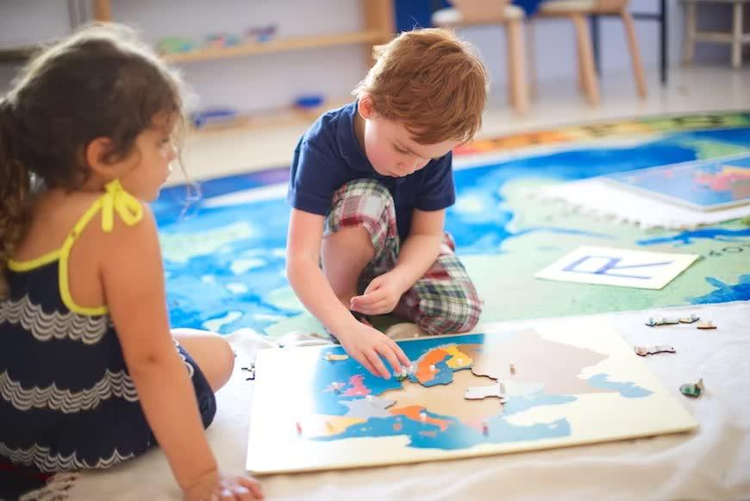

NCCC POLICIES

Enrollment

Priority in enrollment is given to students whose families are affiliated with New College (faculty, staff, students, and alumni). Most of our students are full-time attendees, with the following exceptions:

- Part-time attendance is possible, either two days a week (TTh) or three (MWF), but availability will depend on demand and staffing, i.e. a child wishing to attend two days a week (TTh) can be most easily accommodated if we have another child wishing to attend three days a week (MWF).
- 4-year-olds enrolled in VPK (without additional “wraparound” care) attend five days a week from 9am-12pm.

The school maintains a waiting list for interested families; if you wish to be added to this list for a future semester, please contact the director and hand in a completed registration packet. No spots can be held for future students unless tuition is paid in full for the entire holding period. Once your child has been offered a place at NCCC, the center must obtain a copy of your child’s medical forms (immunization records/religious exemption and physical/well-check) along with a completed registration packet and registration on our online family portal before she or he may attend school.

Tuition
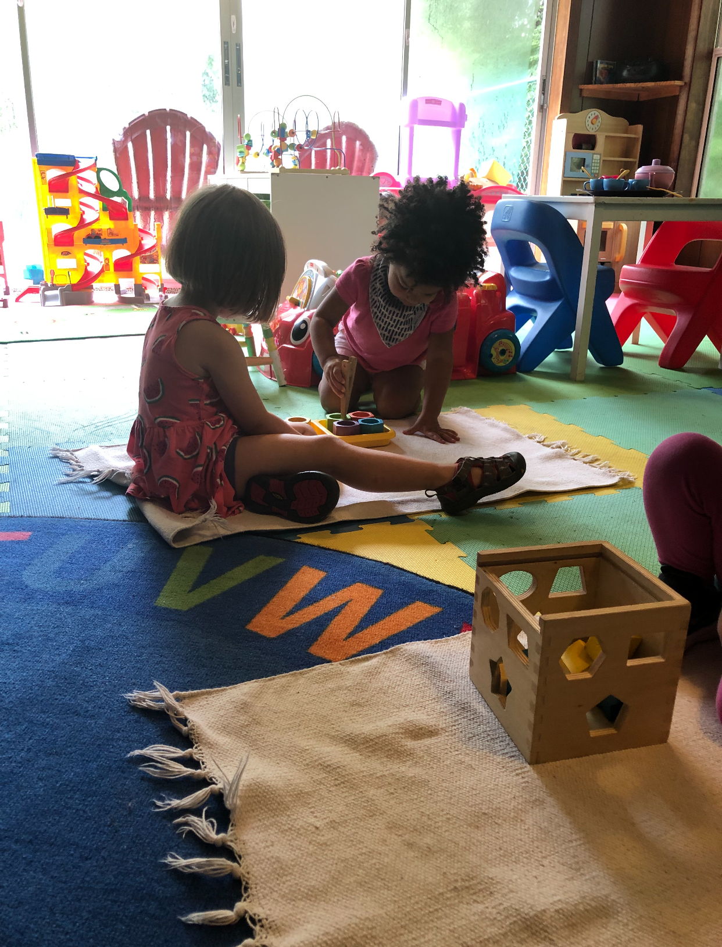
Tuition is due at the beginning of each month. You are responsible for the full tuition payment even if your child misses school because of illness or travel. Full tuition will be charged for months with scheduled vacation days (for example, December and March). However, the first month of school (August) is prorated. As mentioned above, summer program scheduling and rates may vary.

Per tuition policies and procedures, all families are required to register on our Family Portal, and the Center strongly recommends the use of its electronic payments system. If you are using the electronic system, we do ask you to consider using the bank-draft option where possible, since the fees the Center pays on those transactions are much lower than for credit cards.

We offer three ways to pay tuition:

- Autopay: If you supply your bank account or credit card details for secure storage via the Family Portal, you will automatically be enrolled in autopay. You will receive an emailed reminder a few days before the end of the month; NCCC will initiate the appropriate tuition payment on the first day of every month, and you will receive an emailed receipt. This method of payment requires no work on your part.
- Self-Pay: If you wish to use the electronic payments system but prefer to authorize payments yourself each month, please inform us in writing by sending an email to ncchildcenter@gmail.com, whereupon we will remove you from the Autopay list. You can still use your bank account or credit card to pay your child’s tuition, but payments will not be withdrawn automatically; you will need to log in each month to initiate the transaction. You will then receive an emailed receipt.
- Non-Electronic Payments: While the Center accepts non-electronic forms of payment such as cash, personal checks, and money orders, every payment made in this way is subject to a $25 processing fee. Place your payment in an envelope and put it in the secure grey payment box by the front door of the Center. Once your payment is processed, you will receive an emailed receipt.

Overdue Tuition: Every payment submitted after the 5th of the month is subject to a $50 late fee. Further, any family with an account two months overdue will be asked to withdraw their child(ren) from school until the balance is paid; at three months overdue, NCCC will begin the process of pursuing payment by legal means.

Parents will be held responsible for all costs associated with non-payment or failed transactions, including but not limited to returned-check fees, insufficient-funds fees, collections fees, and/or court costs.

Discounts: Tuition is variously discounted for NCF faculty, staff, students and alumni. Current tuition rates can be found at www.newcollegekids.org. To qualify, faculty, staff and students must be currently affiliated, and alumni must hold a New College degree. There is a 20% discount off the additional tuition (beyond the first, largest amount) for siblings simultaneously enrolled at NCCC.

Registration Forms and Initial Deposit

Before your child comes to school, you must first fill out our registration form, available on our website, www.newcollegekids.org (Information>Family Portal>Web Registration) or at the school office. A deposit of $100 is due at the time of registration which will be applied toward the materials fee; this is a nonrefundable fee. You will also need to download, fill out, and submit a registration packet (Information>Downloads) of forms for which we are required to maintain paper copies. Please bring these into school along with your child’s medical forms. All completed forms will be kept in your child’s file. If you decide not to have your child attend NCCC we ask that you let us know as soon as possible.

Medical Forms

According to state law, your child must have an updated physical form and immunization form to attend school. Your child’s pediatrician can provide these forms* and they will be kept in your child’s file.

- The physical form must be completed by a medical provider before your child can attend NCCC. This form will be valid for two years after the physical examination date. It must be updated every two years.
- Additionally, the immunization form or a religious exemption form must be completed before your child can attend NCCC. Up to date immunization forms are required of all students, even those who have qualified for an exemption. Once the immunization or exemption has expired, your child cannot return to the center until an up to date form is provided.

To comply with state law, parents must also be provided with a Flu Brochure that will be handed out at the beginning of the school year. There is a removable section for parents to sign and return, and this will also be kept on file.

*Tip: If you cannot schedule an appointment with the pediatrician in time, the county health department can provide your child with the needed immunizations. As long as you have a scheduled appointment and can provide the director with proof of an appointment, your child may attend school.

Immunization Policy

While we allow students whose families seek a religious exemption to opt out of immunizations, it is our policy to limit the proportion of unvaccinated NCCC students to 2 students per school year in order to protect the health of our overall student population. If an incoming student would cause this limit to be exceeded, we will ask the family to go on a waiting list until we can accommodate them in accordance with this policy. We also strongly urge all eligible family members to get annual flu and covid vaccines.

Family Volunteer Requirement

Our family volunteer requirement provides additional support, helps to build a sense of community, and enhances our program and the premises. We ask that each family contribute a minimum of 5 volunteer hours per academic year to the school if their child attends full-time. The requirement for families of part-time students is 3 hours for students attending three days per week and 2 hours for students attending two days per week.

Examples of ways to volunteer include (but are not limited to) participating during one of the scheduled Saturday clean-up days or fundraising events, completing a special project outside of the classroom (approved by the Director and/or Board), and serving on the board of directors. You know best where your talents lie, so we welcome your creativity in determining your involvement. We also welcome grandparents and other extended family and friends who have talent and time to contribute to help you fulfill the requirement!

Unable to Donate Time? We understand that sometimes it is not possible to donate your time. As an alternative to donating your time, you may send in a check for $250. Families with unmet volunteer hours will be billed at the end of the academic year. All contributions will be applied towards classroom needs, professional development for the staff, and special programs for our students.

If you have any questions or concerns about this requirement, please see the Director.

Calendar
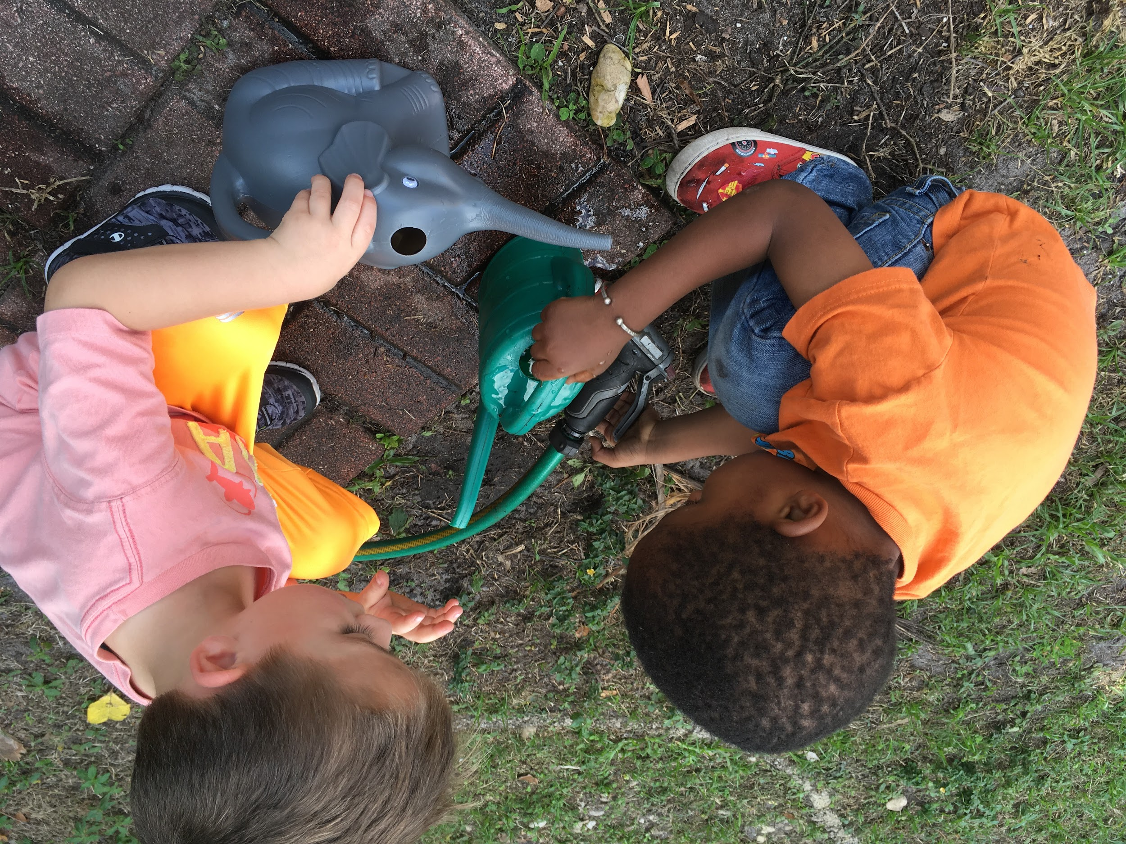
NCCC typically follows the Sarasota County School District and New College of Florida calendars, with a preference for New College’s calendar in cases where these do not align. The calendar includes seven holidays—Labor Day, Thanksgiving, Winter Break (two weeks), Martin Luther King Day, Presidents’ Day, Spring Break (1 week) and Memorial Day—and possibly up to three professional days. We use our professional development days to encourage our staff to visit other schools, make changes to the learning environment, provide workshops to our staff in movement and dance, in lessons with our materials, and in classroom management skills.

In the event of a hurricane or other expected catastrophic weather, the director will decide whether NCCC will be open, and parents will be notified by email in advance.

Confidentiality

At NCCC, confidential and sensitive information is only shared with our teaching staff on a “need to know” basis in order to care for your child most appropriately and safely. Confidential and sensitive information about staff, other families and / or children will not be shared with families as the center strives to protect everyone’s right to privacy. Confidential information includes, but is not limited to, names, addresses, telephone numbers, disability status, and other health-related matters of anyone associated with NCCC.

Outside the center, confidential and sensitive information about a child will only be shared when the child’s family has given written consent, except where required otherwise by law. Whenever sharing of information outside the center becomes necessary, families will be informed as to what information has been shared, with whom, and why.

Cultural Diversity

At NCCC we believe that it is good for children to receive culturally sensitive care with a global, multiethnic view that respects different beliefs and lifestyles. We not only respect the various categories outlined in our non-discrimination statement (above) on legal grounds; we think it is crucial for children to understand and respect difference in our families and staff—whether with respect to race, culture, gender identity, sexual orientation, or other category. We therefore encourage a school environment in which such differences are recognized, celebrated, and able to thrive.

The building of such respect requires that adults in children’s lives work together to understand each other’s perspectives. We recognize that program and family values may differ, and work together to blend different value systems. Everyone who works with children is both a teacher and a learner, so this process requires ongoing dialogue, with all involved listening carefully to one another.

Mandated Reporting

Under the Child Protective Services Act, mandated reporters—a category which includes all NCCC staff—are required to report any suspicion of abuse or neglect to appropriate authorities. Staff are not expected to investigate or discuss any suspicions with families prior to making a report. Under the Act, mandated reporters can be held criminally responsible if they fail to report suspected abuse or neglect. This responsibility is taken very seriously and we will make all warranted reports to the appropriate authorities, as well as cooperate with any investigations.

Staff Behavior

We expect our staff to maintain a professional relationship with the children, families and each other. Please alert the director or current president of our Board of Directors if you feel that our staff is acting in an unprofessional manner or if you feel that you have been treated with a lack of professionalism. We ask our staff to wear attire that is free from holes that would expose undergarments or parts of the body considered private, and that is also free of language that is inappropriate for families—after all, many of our children become proficient readers! Staff are trained on appropriate forms of touching (for example, we do not coerce hugs from children), and no staff member is ever alone with a child behind a closed door. We also require honesty from our staff, even if we have made mistakes we aren’t proud of. Please let us know if you feel that you haven’t heard the whole truth about any incident involving your child or children.

Concern Reports: If a parent has any concerns or complaints about a staff member at the center, they are encouraged to discuss these with the director. Any serious concern involving the safety of students at the center may also be reported directly to the Department of Children and Families (DCF). For other concerns, the parent may wish to file a concern/grievance report, which will be kept on file at the center. The employee about whom the report is written will have the opportunity to read the grievance and write a response, which will also be kept on file. Any concerns about the director should be brought to the attention of a member of the executive board of directors.

Illness
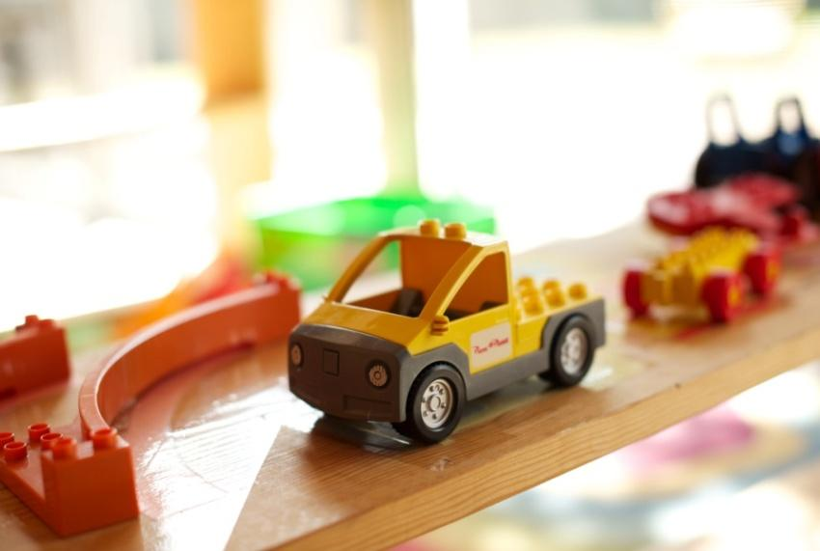
To help keep the children and staff healthy we ask that parents wait 24 hours before sending a child to school after their last vomiting incident or fever over 100 degrees. We will contact parents to come pick up children whose fevers at school have gone over 100 degrees, who have vomited, who have diarrhea that is loose enough to get through a diaper or pants, or whose coughing is so severe that a child cannot catch his breath. A lingering cough that isn’t contagious anymore is fine, as are any children who have been cleared to come to school by their pediatrician. When a child has been home from school for two or more days due to illness please provide the school with a doctor’s note stating the child has been cleared to return to school.

Head Lice

We have a strict “no-nit policy” at NCCC. Parents of students who are found to have any head lice or nits (lice eggs) during one of our periodic checks will be asked to pick them up from school. Students may not return to school until they are nit-free. In other words, parents must not only follow the usual recommendations for shampooing hair and washing bedding and clothes; they must also comb the child’s hair free of nits. This is an arduous process, but it is to the benefit of everyone at NCCC. Information about head lice and how to treat them is available from the NCCC director.

Medication

While all of our staff get training in first aid and CPR, without a signed medical release form we are restricted to using only soap, water and Band-Aids. Medical release forms are available for download from our website (Information>Downloads) or in the NCCC office; they must be dated, signed by a custodial parent or guardian, and contain the child’s name, the name of the medicine dispensed, as well as the date, time, and dosage to be given. A copy is also provided to parents in their registration / enrollment packet.

All medications sent to the school must be sealed and unopened with the child’s name written on the container. Syringes or spoons must be provided with the medication, if applicable.

With a signed release form we are able to dispense prescription and non-prescription medication—this also applies to sunscreen and insect repellent! The school will use one type of sunscreen and bug spray approved by the director for all children, unless a parent specifically supplies their own sunscreen and/or bug spray for their child.

Food & Food Allergies

We are a nut free school, and we ask that parents inform us of any food allergies their child might have under “Allergies” on our registration form. If your child must have a specialized diet, please provide a note from a physician with specific food requirements or restrictions and a copy of a meal plan that considers the special diet.

We also ask parents to refrain from sending sweets to school with their children. Please do not send in cookies, candies, or items containing layers of chocolate, chocolate chips, marshmallows, etc.

Discipline & Guidance

The preschool years are the foundation for everything in a child’s life—not only how children feel about themselves and others, but how they treat others, at the same time as they are beginning their academic careers and their socialization outside the home environment. To this end children at NCCC are never humiliated, teased, embarrassed, or subjected to any form of corporal punishment to encourage an understanding of expected behaviors. They are also never denied food, rest, or access to care.

Our first method of helping children to make appropriate choices is to model those choices for them. The staff model polite speech and kind, gentle actions to support children as they meet frustration, disappointment, sadness, or differing perspectives. We collaborate with the older children to make the rules of the classroom each year and remain consistent in enforcing those rules. As a very last resort, the staff uses time outs for children old enough to understand enough language for time outs to be beneficial. We collaborate with each other, parents, and children to develop a caring community in which there is respect for each other and our environment.

Accidents & Injuries

Our web registration form asks for your child’s medical history, doctor information, and other details in case of need. In the event of any serious emergency, you (or, if necessary, someone else on your authorized contact list) will be contacted immediately by the director or a teacher, and an Incident or Accident Report will be filled out. Non-emergencies not warranting a parental phone call will simply be reported via Incident Report. This is a form that allows us to communicate the details of any incident or accident that parents would want to know about. The teacher writing the report will sign it, as will the director or assistant director. The report will then be attached to your child’s sign-in sheet for your review and signature (confirming proof of notification). Please return signed Incident Reports to a staff member; per Florida state law, these are kept in your child’s file for one year after the event.

Photos & Videos

NCCC wishes to support its students and their families as they seek to balance concerns about privacy with today’s media-rich society. Your registration packet includes a “Photo, Video, and Information Release Form” that asks you to clarify specific instances in which we may (or may not) use your child’s name and/or photograph—for example, in photographs posted at the Center, on the Center’s website, Facebook page, or on promotional materials.

Security Cameras

For the safety and security of students, staff, and premises, the center utilizes a closed circuit camera system with coverage in all classrooms. The video feed is secure and only viewable from the director’s office station; no video is ever transmitted over the internet or local networks, and recordings are only kept locally. In the event of an emergency or investigation, recordings are available to the director, and may only be made available to other individuals pending approval of the board of directors. Recordings are kept for 30 days maximum.

Emergency Preparedness & Response

The NCCC staff receive emergency notifications via the New College of Florida alert system; established procedures and regular drills guide how particular emergencies are handled. For example, if a hurricane is expected, the director will decide whether NCCC will be open, and will alert parents by email. In the event of a tornado warning, students and staff will gather in two interior hallways in the NCCC building until the all-clear is sounded; if there is time, we also have permission to take shelter in Chae Auditorium in the New College Heiser Science Building, an official campus emergency shelter. In the event of a school evacuation or active shooter on campus, the students will evacuate the building and meet parents at the following pick up locations: (1) Primary location is the Asolo theater parking lot. (2) Secondary location is the NCF police department building (aka “cop shop”). See the map below.

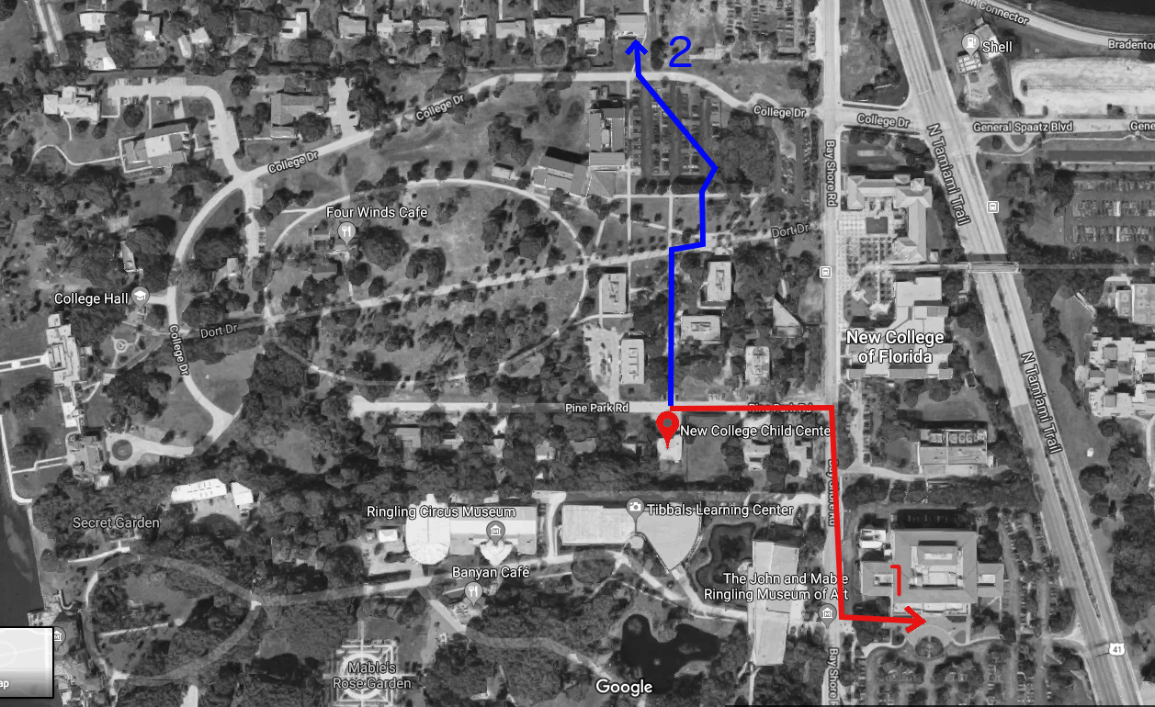

SCHOOL PROCEDURES

What To Bring

A child new to NCCC will require the following, all of which should be labeled in permanent marker with your child’s name or initials:

- Two full changes of clothes in a ziploc bag;
- A daily lunch and 2 snacks;
- A water cup/bottle;
- Closed-toe shoes;
- A blanket for napping;
- A hat, if desired for use in the sun;
- (Optional) Sunscreen and/or insect repellent with signed release forms authorizing their application; otherwise your child will use those provided by the center (though authorization forms are still required for these);
And, if used by your child:
- Diapers in a bag or container labeled with your child’s full name;
- A packet of wipes;
- A bib;

These items and their use are all discussed elsewhere in this Handbook, but they are aggregated here for the convenience of new NCCC families.

Cubbies

Each child will have a labeled personal cubby. Their cubby is a space to store lunch bags, a change of clothes, school work and workbooks only. Please do not put water bottles in the cubbies. These tend to leak making everything in the cubby wet. There is also a file box near the sign in and out book where you can check for important papers or messages from the director and staff, along with any work your student has done. Please check your child’s cubby and file each day at pick up and remove all paperwork, art work and any correspondence from staff.

Clothes and shoes

All children should have two full changes of clothes in a labeled ziploc bag. We’re happy to launder wet or soiled clothes, but please make sure you keep your child’s cubby stocked with weather-appropriate clothes. You are welcome to send your children in whatever footwear you choose, though children are required to wear some kind of shoes at the center at all times in case we need to exit the building in an emergency. Closed-toe shoes should be worn or brought to school for outdoor play and field trips. Please send your children in clothing appropriate to seasonal weather. Rain gear shouldn’t be necessary, but rain boots are fine.

Labeling

Please, please label everything that comes into school so we can get it back to you—clothes, lunch/snack containers, toys, bedding, cups, everything!

Food
We have a water fountain and disposable cups to keep a steady supply of water for the children; we prefer that you send in a sippy cup or bottle labeled with your child’s name. Lunches should be brought from home, along with a morning snack and an afternoon snack if your child is attending after 3:00 pm each day, in a non-breakable container (no glass, please!). Per regulation, the center is prohibited from heating food and has limited refrigerator space, so we ask that any food that should be kept either cold or warm be sent with an ice pack or in a thermos. If your child uses a bib, you may send in a plastic or waterproof bib labeled with his/her name, which will be kept in the lunchroom and washed every afternoon.

Treats: We teach about nutrition, and while we also teach that treats are okay once in a while, we ask that parents refrain from sending candy, chocolate or any other sugary treats to school. Please do not send in cookies, candies or items containing layers of chocolate, chocolate chips, marshmallows, etc. When celebrating birthdays, we ask that parents bring only healthy treats, like fruit, muffins or veggie snacks. The director and staff are more than happy to share creative ideas for healthy treats!

Hand-Washing

Our staff will wash their hands whenever they come in to start a shift, before they handle anyone’s food, after they assist with diapering or in the bathroom, after helping a child with a runny nose, after they use a cleaning product, after they come in from outside, and after they otherwise expose themselves to germs (blowing their own noses, after using the restroom, etc.).
Children will wash their hands after using the toilet, after blowing their noses, before eating, after coming in from outside or handling an animal, or after coming into contact with any other item that might spread germs.

Diapering

Parents should supply diapers in a bag or container labeled with the child’s name, along with wipes. We will let you know when your child is running low on diapers or wipes either by sending you an email or leaving a sticky note on your sign-out sheet.

Toilet Training

Our staff is happy to help you toilet train your child. We don’t give candy treats for a bathroom trip or “potty party,” but we’re happy to have a sticker chart on the wall if you’d like to supply some stickers for us to put on it. Please send extra (labeled) underwear when we’re at this stage. We will be happy to launder soiled clothes if we have time before pick-up.

Drop-Off & Pick-Up

During the school year, the school is open from 7:45am to 5:30pm. It is very important that all children be picked up by 5:30 PM. If you are late to pick up your child, you may be charged a $20 fee plus $1 per minute past 5:30 PM. If you have not called the center and your child has not been picked up by 6 PM the staff will notify Sarasota Police, who will then take custody of your child until you are able to come get them. Please close the door behind you when you enter and try to minimize the disruption of any organized activity (such as circle time) that is happening while you drop off or pick up your child. If your child has work materials out at pick up time, please help them to put the materials away before leaving.

Every day each child must be signed into school at drop-off and signed out at pick-up. The sign-in/out book can be found by the door. On the school enrollment form, you will be asked to list anyone (apart from the child’s parents or legal guardian) whom you authorize to pick up your child from school; for legal reasons we are unable to allow anyone not on this list to remove your child from the school. It is our policy for staff members to check the ID of anyone attempting to pick up a child whom they have not met previously. If someone is picking up your child, please make sure they are carrying a picture ID. In the event of an emergency or unexpected event you may grant temporary permission for an adult to pick up your child. You must send in a written note or email with the person’s full name and contact information and the date they will be picking up.

Parking

When you are dropping your child off or picking him/her up, please try to park in the NCCC driveway. New College parking enforcement may ticket 1) anyone parking in the spaces on the far side of the street without a New College parking tag, and 2) anyone parking on the grass on the far side of the street, regardless of whether the car has a New College tag or not. Parking on the grass on the NCCC side of the street is more of a grey area, but it is still safest to park in the driveway. At busy times of day (especially right around 5pm), we encourage parents already parked in nearby lots (Heiser, ACE, Palmer) to walk over to retrieve their children rather than driving. Please do not leave children under 10 years old unattended in the parking lot as we are mandated to report any such situation.

Daily Schedule

Schedules change from year to year, but here are sample schedules for a typical day, excluding special activities like movement or language lessons. Daily schedules are displayed in each classroom for your review.

 | Explorers |  | Scientists
7:45-8:30 | Arrival and Free Play | 7:45-8:45 | Arrival, Table Toys
8:30-9:00 | Diaper/Restroom | 8:45-9:00 | Writing Practice
9:00-9:45 | Snack, Handwashing | 9:00-9:30 | Morning Group
9:45-10:00 | Circle Time | 9:30-9:45 | Snack
10:00-10:30 | Diaper Change, Free Play | 9:45-10:15 | Group Activities (Art, Science)
10:30-11:15 | Outside Play, Handwashing | 10:15-11:15 | Centers
11:15-11:35 | Planned Activity | 11:15-11:45 | Outdoor Play
11:35-12:30 | Handwashing, Lunch | 11:45-12:30 | Handwashing, Lunch
12:30-1:00 | Diaper/Restroom | 12:30-1:00 | Story time
1:00-2:45 | Nap | 1:00-2:15 | Nap
2:45-3:15 | Wake Up, Restroom | 2:15-3:15 | Quiet Activities
3:15-4:15 | Snack, Handwashing | 3:15-3:45 | Snack, Handwashing
4:15-4:45 | Circle Time | 3:45-4:45 | Afternoon Projects (Art, Music)
4:45-5:30 | Outside/Free Play, Dismissal | 4:45-5:30 | Table Toys, Clean up, Dismissal

Napping

We will do our best to help your child get some rest (and hopefully sleep), but there is no mandatory maximum age for our nap room. We will also be happy to wake your child up after a specified length of time. We will encourage each child to rest for a minimum of thirty minutes. We have activities for children who do not fall asleep and have rested for the minimum time. We ask that parents send labeled child size blankets for nap time; do not send in a pillow. One silent sleeping toy is welcome at naptime, it must be small enough to fit into the cubby.

Toys, Books, & Sharing

While children should not bring toys from home, we allow children to bring books to school and we let them choose whether or not to share those books and with whom. We do not force children to share, but we do positively encourage it.

Birthday Celebration

We will be happy to celebrate your child’s birthday at the center. You may discuss what to bring with the director in advance. Please also see the Food: Treats section above.

Staff Babysitting

This is done purely as a convenience for parents and staff; NCCC does not oversee or vouch for such private arrangements. Furthermore, to prevent conflicts in scheduling, please do not ask staff to babysit during school hours.

FAMILY INVOLVEMENT

Participation

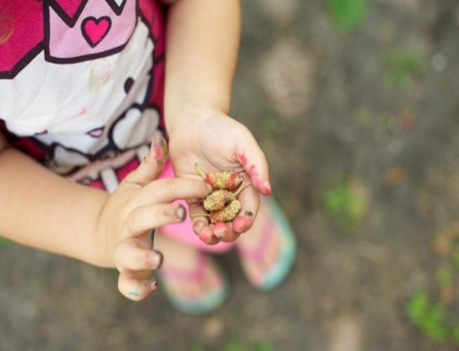
Parents and other family members are always welcome to come and spend time with their children at school—for circle time, work time, lunch, or whenever. Please let the director or teachers know if you would like to spend an extended amount of time at the center. In addition, parents are always welcome to call the school to check up on their children. Please ask the director any questions you might have about curriculum and about any specific lessons you are interested in knowing more about. The Director will host a Back-to-School event at the beginning of the fall semester, to discuss goals for the upcoming year.

Parent-teacher conferences: at least twice throughout the academic year, an email will go out inviting parents to schedule a conference with their child’s teacher. We do not require that you stick to that schedule, however; if at any time during the year you would like to meet with your child’s teacher, please talk to him/her or call the school to schedule a conference.

Communication

The school staff communicates with families in a variety of ways. Children in the lower classroom receive daily report sheets indicating what they ate at morning snack, lunch, and afternoon snack time, as well as how long (or if) they napped, and what they did during the day. (These reports are not provided for the upper class, as students are generally verbal.) If your child is in the VPK program, you will also receive copies of the beginning-and-end- of-year assessments we are required to do as part of that program.

If your child becomes sick and needs to come home, or is seriously injured, you will receive a phone call (and probably also an email). Lesser issues are generally reported via the daily report or sign-in log; incident reports are generally attached to your child’s sign-in sheet, as are sticky-note requests for more diapers or wipes. All other communications about the school, especially announcements from the director, teachers, and board president, will come to you via email.

If you have any concerns about poor behavior at school—if you see something while you are there, or your child comes home and tells you about something someone did to him/her, or someone else—please tell the director or one of the teachers rather than address it directly with the relevant child(ren) and/or parent(s). Please do not discipline any child other than your own.

First Day of School

The first day is probably going to be harder on the parents than the children. Your children will have new friends and toys to play with and lots of engaging new experiences. You are always welcome to call and see how your child is doing, and we will try to give you a few updates on your child’s first day and their progress. Your attitude and choice of words can really help your child’s first days to be more successful. Remember to stay positive rather than acting anxious, and let them know that you are excited for them to have fun at their new school!

Third-Day Blues

This is a well-known phenomenon in preschool behavior. For the first two or three days that a child comes to school, they often have a much easier time than parents expect, but then experience the anxiety about coming to school that we thought they might feel on the first day. It’s a perfectly normal reaction; just remember to stay positive and it should disappear quickly. The more often a child attends, the more quickly they will get accustomed to being at school.

Special Events

Costume Parade: Children are encouraged to come to school in costume, and are taken around campus to predetermined areas where they can give out fun stickers to the college students. This is done in place of Halloween. The children learn to give and the college students feel appreciated when given the gift of a sticker. It is a fun community building opportunity for the children.

Valentine’s Day: Children are given the opportunity to give out Valentine’s Day cards and such. If they wish to do this, please make sure to include everyone in your child’s class. If you would like to send some kind of special Valentine’s gift for your child to give out, such as stickers or pencils or similar items, that’s just fine, but please don’t send in candy, as we will not allow them to pass it out.

Class Pictures: These are usually taken at least once each school year. Parents will have the opportunity to order individual prints and/or packages.

End-of-Semester Parties: We often schedule an all-school party at the end of the school year. Parents are asked to sign up to bring a potluck dish or other contributions, such as cups or plates.. These are a fun opportunity to mingle informally with other NCCC families and staff, and sometimes include a performance. These events differ from year to year; all parents will be advised of the type of celebration at least two weeks prior to the end of the semester.

